CS-340 Project Two Dashboard: Grazioso Salvare

Developer: Celeste Wally

Project Overview
This project delivers an interactive dashboard for the client Grazioso Salvare to support animal rescue operations. The dashboard connects to a MongoDB database containing animal outcome data and allows users to filter, visualize, and analyze information related to specific rescue missions. The dashboard follows the MVC (Model-View-Controller) architecture:
- Model: MongoDB via PyMongo for storing and retrieving animal records
- View: Dash components including data table, pie chart, and map
- Controller: Custom crud.py Python module with callbacks to query the database
Key functionality includes:
- A dynamic Dash DataTable showing animal details
- A dropdown menu to filter animals by rescue type
- A pie chart visualizing breed distribution
- A map displaying selected animal locations
- A reset option to restore the full data view

Tools and Technologies Used
Tool / Technology | Purpose
Python | Main programming language for application logic
Pandas | Data manipulation for MongoDB records
Dash (Plotly Dash) | Framework for building the interactive dashboard
Plotly Express | Creates pie chart for breed analysis
Dash Leaflet | Integrates map view for animal geolocation
Dash DataTable | Displays shelter animal records in a paginated, interactive format
MongoDB | NoSQL database to store animal records
PyMongo | Interface to perform CRUD operations on MongoDB
Jupyter Notebook | Development and testing environment for dashboard
Base64 Encoding | Used to embed the Grazioso Salvare logo into the dashboard

Why MongoDB?
MongoDB's document-oriented design supports flexible and dynamic animal data records. Using PyMongo, we can query documents efficiently and manipulate them as Python dictionaries, streamlining development. Its schema-less nature suits the variability in animal data fields.

Why Dash?
Dash was selected for its tight integration with Python, support for rich data visualizations, and simple callback structure. Its component-based design made it easy to build a clean, interactive UI with tables, dropdowns, and charts that respond in real time to user selections.

Setup Instructions
- Download or clone the project files.
- Install dependencies:
pip install dash pandas pymongo dash-leaflet plotly jupyter_dash
- Ensure MongoDB is running and contains the AAC.animals collection.
- Open ProjectTwoDashboard.ipynb in Jupyter Notebook.
- Run the notebook to launch the dashboard locally (e.g., http://127.0.0.1:11163/)
- Use the dropdown to explore animal data by rescue type.
- Select a table row to update the map and charts dynamically.

Screenshots Included
- Starting State (Reset): Full dataset with all UI components displayed
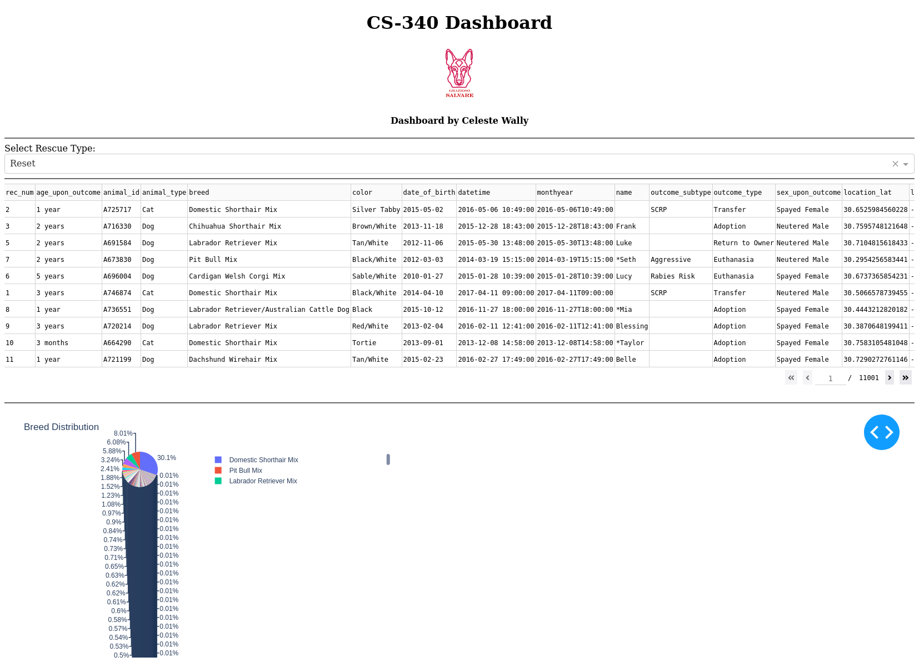
- Water Rescue: Shows Labrador Retriever Mix records on map and chart
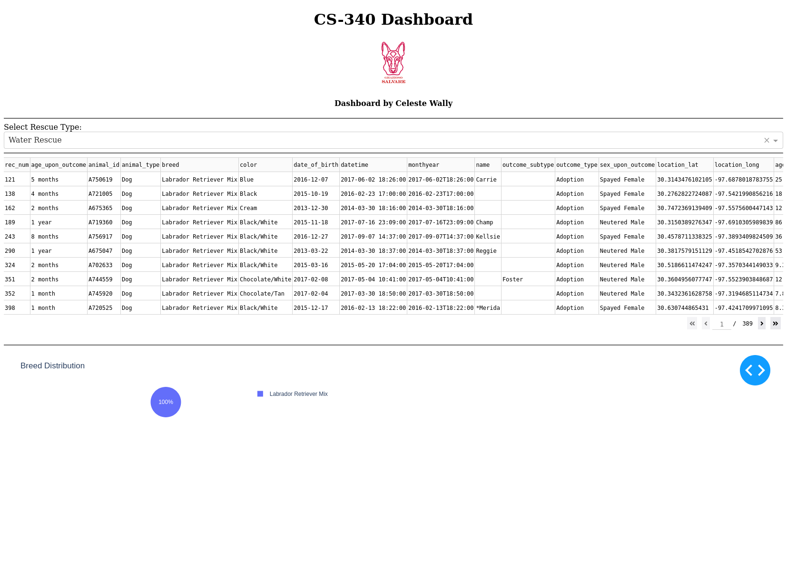
- Mountain or Wilderness Rescue: Shows German Shepherd data
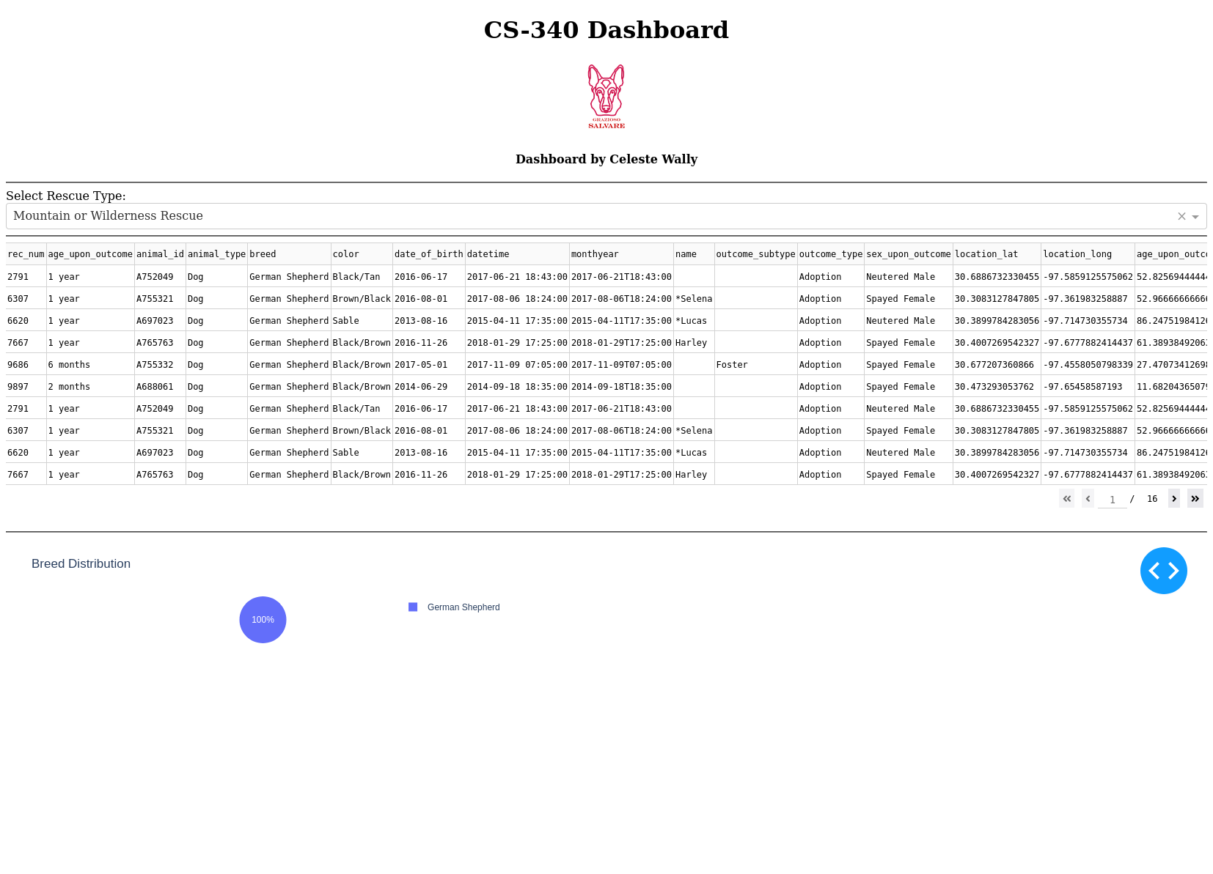
- Disaster or Individual Tracking: Filters for breeds used in disaster operations
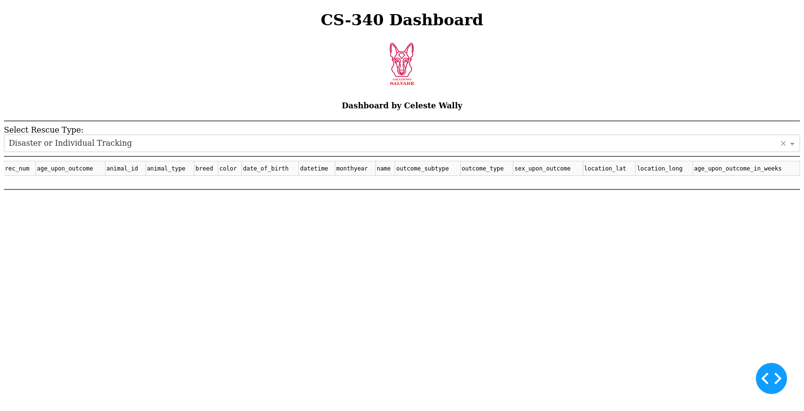
Each screenshot contains:
- Grazioso Salvare logo
- Developer identifier (Celeste Wally)
- Functional table, dropdown, map, and pie chart

Steps to Completion
- Developed crud.py module with MongoDB read capability
- Created dashboard layout with Dash components
- Added base64-encoded logo and developer name
- Implemented filter callbacks for the dropdown and reset
- Built pie chart and map with dynamic updates
- Conducted thorough testing for each filter and state

Challenges and Solutions
- Map Errors: Fixed by using valid lat/long data and correcting row selection logic
- Empty Filters: Added default resets and checks to prevent chart/map crashes
- Logo Loading: Resolved file not found errors by placing the image in the correct directory and using proper encoding

References
- Dash Docs: https://dash.plotly.com
- MongoDB Docs: https://www.mongodb.com/docs
- Plotly Express: https://plotly.com/python/plotly-express/
- SNHU CS-340 Course Materials

Final Notes
This dashboard equips Grazioso Salvare with an efficient, visually-driven platform for evaluating animals based on rescue needs. With easy-to-use filters, clear visualizations, and live data updates, the tool supports fast, informed decision-making for mission readiness.

